MARTIN L. KING, JR.
ABC BIOGRAPHY
BOOKLET
By
Last Name, First Name
Date
Period

A is for Alberta which was Martin Luther King, Jr.’s mother’s name. Her parents were Rev. A.D. Williams and wife Jennie who lived in a prosperous section of Atlanta known as “Black Wall Street”.

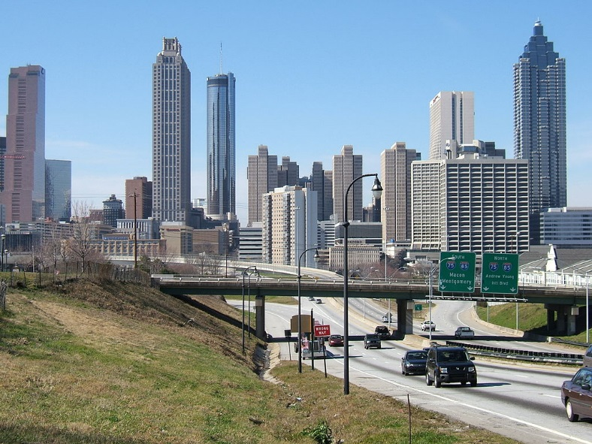
B
MLK, Jr. was born on January 15, 1929 in Atlanta, Georgia to Michael King, Sr., and Alberta Williams, a Spelman College graduate and former schoolteacher. He was raised in a nurturing home with his parents and siblings.
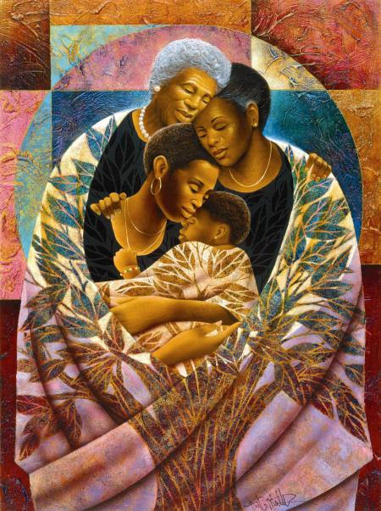
C
MLK, Jr. was the charismatic leader of the Civil Rights Movement in the United States. He was chosen to lead the Montgomery Bus Boycott in 1955.
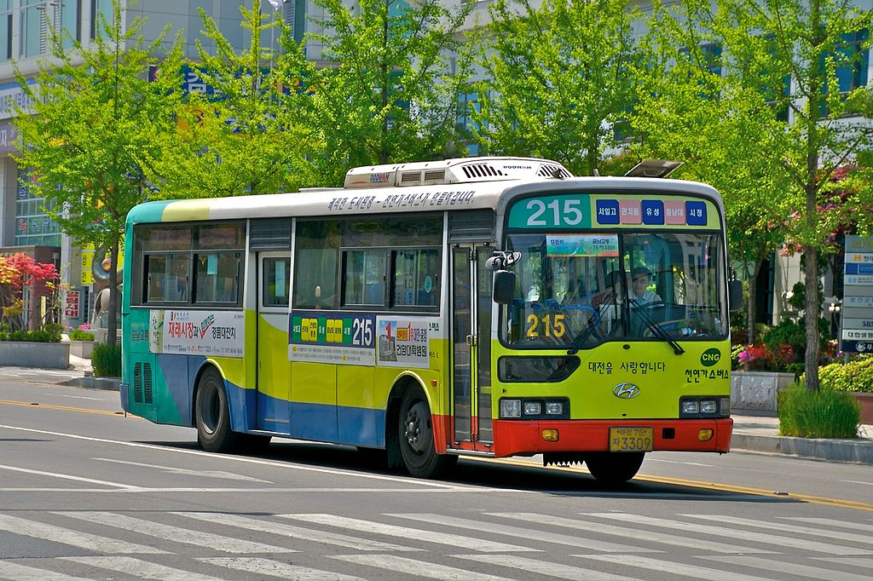
D
King delivered his first sermon at the Dexter Avenue Baptist Church in Montgomery, Alabama in January 1954 and in April he agreed to accept a pastorship following completion of his doctoral thesis.

E
When Rev. A.D. Williams, MLK, Jr.’s grandfather died of a heart attack in 1931, his son-in-law King, Sr. became pastor of Ebenezer Baptist Church where he served for 44 years.

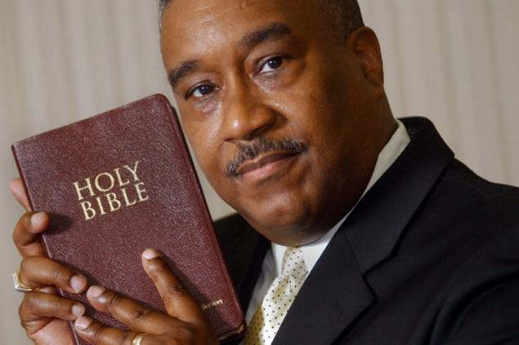
F
King’s father was a great role model for him. King, Sr. was involved in the local chapter of the NAACP and had led a successful campaign for equal rights of white and black teachers.
G
Martin grew up in Atlanta, Georgia was named Michael Lewis until he was five. He thrived with his siblings in a secure middle class family and had a normal, happy upbringing.
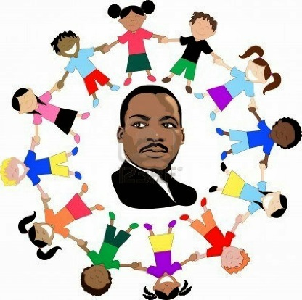

H
King delivered over 2,500 speeches addressing America’s racial injustices with I Have a Dream being his ost memorable. Martin Luther King, Jr. was a hero to many people.
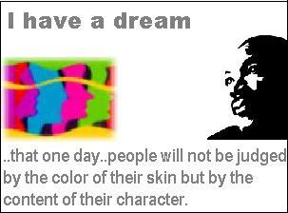
I
In 1934, King, Sr. attended the World Baptist Alliance in Berlin. When he returned to Atlanta, King, Sr. changed his name and his son’s name from Michael King to Martin Luther King, after the Protestant reformer.
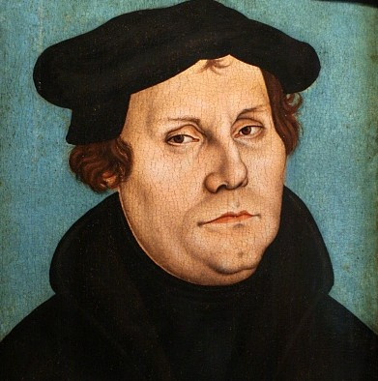
J
MLK, Jr.’s grandmother Jennie, whom he affectionately called “Mama” was especially protective of her first grandson. Likewise, King closely bonded with his grandmother, classifying her as “saintly.”
K

